IT SUPPORT PORTFOLIO

Project 001
Windows Performance Troubleshooting
Practical case study • Diagnostics • Startup optimization • System-file repair

Project details | Information
Device | TM1 laptop
Operating system | Windows 11-style interface; Command Prompt reported Microsoft Windows Version 10.0.26200.9168
Main issue | Laptop had previously experienced freezing and unresponsiveness
Project type | Personal hands-on troubleshooting lab
Status | Significant improvement reported after troubleshooting; continue monitoring

This is a truthful record of guided practice, not paid employment or client work.

1. Project overview
The aim was to investigate a TM1 laptop that had been slow, freezing, or becoming unresponsive. The lab followed a structured support process: identify symptoms, collect system information, inspect processes and startup apps, make limited changes, run a Windows diagnostic, restart, and verify the result.

Objectives
- Inspect CPU, memory, storage, and running processes using Task Manager.
- Review applications configured to start automatically.
- Disable only startup apps the user did not need to launch automatically.
- Run System File Checker (SFC) and interpret its result.
- Compare observations before and after troubleshooting.

2. Initial system assessment
Item | Observed information
Installed RAM | 4.0 GB LPDDR4
Usable RAM shown | Approximately 3.8 GB
Memory speed | 2400 MT/s
Initial memory in use | 2.7 GB (approximately 71%)
Initial available memory | 1.1 GB
Storage | SATA SSD
CPU | Fluctuated; user observed readings from single digits to occasional peaks above 90%. Later snapshots showed low single-digit usage.
Graphics | Intel UHD Graphics

Interpretation: 4 GB RAM is limited for modern multitasking. Initial memory use around 71% left relatively little headroom. This may contribute to slowdowns when more applications are opened, but does not by itself prove a hardware fault.

3. Running-process inspection
Task Manager > Processes was inspected with the Memory column sorted from highest to lowest. One screenshot showed total memory utilization of 73%. Visible process readings included:
Process | Memory shown
WhatsApp (10) | 134.8 MB
Microsoft Defender Antimalware Service | 104.2 MB
Search (7) | 81.8 MB
Task Manager | 55.7 MB
Desktop Window Manager | 45.2 MB
Start | 45.1 MB

No single visible application accounted for an unusually large share of total RAM. The overall memory constraint appeared more relevant than one obvious memory-heavy application. Process usage changes dynamically.

4. Startup-app assessment and changes
Startup entry | Initial status | Decision / action
Microsoft 365 Copilot | Enabled | Left enabled; not investigated further.
OneDrive | Enabled; High impact | Disabled after confirming it was not used for synchronization.
SecurityHealthSystray | Enabled; Low impact | Left enabled for Windows Security notifications.
Update | Enabled; Not measured | Left enabled because its associated application was not established.
WhatsApp | Enabled | Disabled after confirming the user did not want automatic launch.
Intel Graphics Command, Teams, Phone Link, Terminal, Xbox | Disabled | No change.

Disabling OneDrive and WhatsApp startup does not uninstall either application or delete files. They can still be opened manually.

5. Post-restart observations
Metric | Earlier observation | Post-restart observation
Memory utilization | 71% on Memory page; 73% on another Processes snapshot | 64% on Processes page; approximately 63% on Memory page
Memory in use | 2.7 GB | 2.4 GB
Available memory | 1.1 GB | 1.4 GB
CPU | Variable, with occasional high spikes reported | 5% on one screenshot; 8% on another

The later snapshot showed approximately 300 MB less memory in use and approximately 300 MB more available memory than the initial Memory-page snapshot. These are observations at different times, not a controlled experiment. The change cannot be attributed solely to disabling startup apps; background activity and timing also affect memory readings.
The user reported the laptop felt slightly better after the first restart and significantly faster after the SFC scan and subsequent restart. This is a user-reported improvement; longer-term stability remains to be monitored.

6. Windows system-file diagnostic (SFC)
An elevated (Administrator) Command Prompt was opened and this command was run:
sfc /scannow
The scan reached 100% verification and returned:
“Windows Resource Protection found corrupt files and successfully repaired them.”
Interpretation: SFC detected corruption in protected Windows system files and successfully repaired the files it identified. This is a confirmed finding. It is not proof that the corruption was the sole cause of the freezing.
The SFC output stated that further details are recorded in C:\Windows\Logs\CBS\CBS.log.

7. Outcome and current assessment
The user reported that the laptop felt significantly faster after the system-file repair and restart. Recorded memory utilization was lower than the initial snapshot. This is a positive observed outcome, but the original symptom should be monitored during normal use and multitasking.

Remaining concern
The laptop has only 4 GB RAM. This remains a hardware capacity limitation and may restrict multitasking. Confirm the exact TM1 model and manufacturer specifications before considering an upgrade. LPDDR memory is often soldered, so upgradeability must not be assumed.

8. Recommended follow-up checks
- Use the laptop normally for 1–2 days and record whether freezing returns.
- If freezing returns, note which applications were open and inspect Task Manager at the time.
- Check Windows Update status and available storage space.
- If symptoms persist, consider a DISM health check followed by another SFC scan, with careful guidance.
- Confirm the exact TM1 model and manufacturer specifications before making hardware-upgrade decisions.

9. Skills demonstrated
- Using Task Manager to inspect CPU and memory utilization.
- Reading process-level memory usage.
- Reviewing and managing Windows startup applications.
- Using Command Prompt with administrator privileges.
- Running System File Checker (SFC).
- Interpreting diagnostic output and documenting findings.
- Comparing pre- and post-troubleshooting observations.
- Following a structured process without disabling unknown system services.

10. Portfolio-ready case-study summary
Investigated a Windows laptop experiencing slow performance and intermittent unresponsiveness. Used Task Manager to review CPU, memory, and running processes; identified a 4 GB RAM configuration and reviewed startup applications. After confirming automatic launch was unnecessary, disabled OneDrive and WhatsApp startup entries while leaving Windows Security and unidentified update entries enabled. Ran System File Checker from an elevated Command Prompt; SFC found corrupted protected system files and successfully repaired them. After restarting, memory utilization was observed at approximately 63–64%, compared with earlier readings of 71–73%, and the user reported a significant improvement in responsiveness. The system will be monitored for recurrence. This was a personal practice lab, not paid client work.

11. Evidence screenshots
Screenshots supplied during the lab are included below as evidence. Photos may be angled or have screen glare; measurements are transcribed from the clearest views.
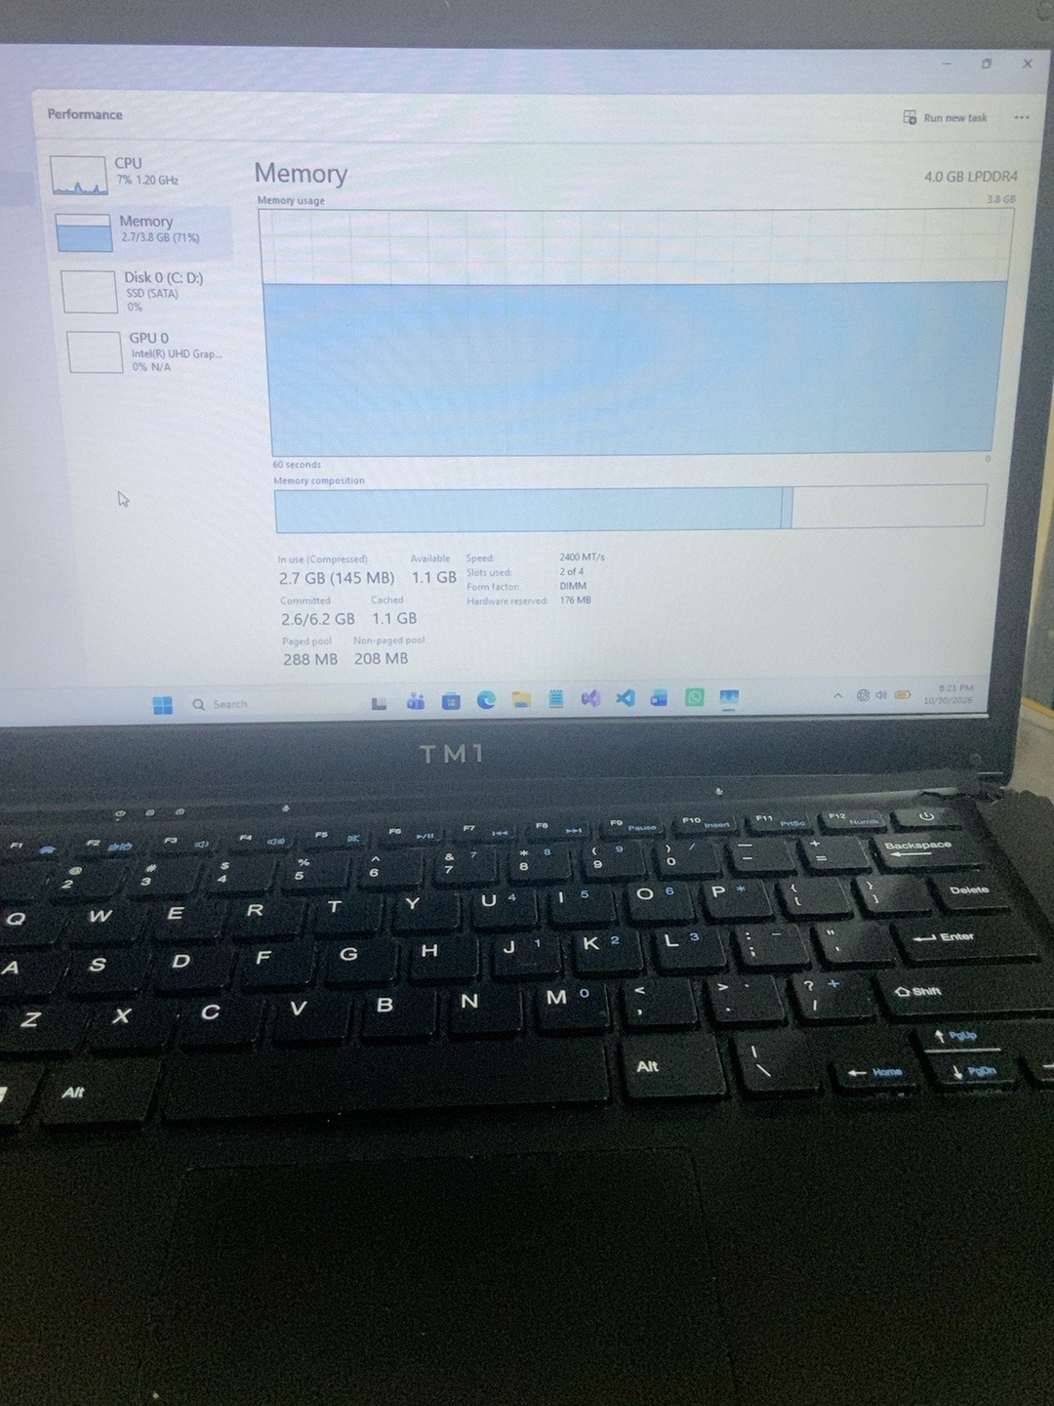
Evidence 1 – Initial Memory view: 4 GB RAM, 2.7 GB in use, 1.1 GB available.
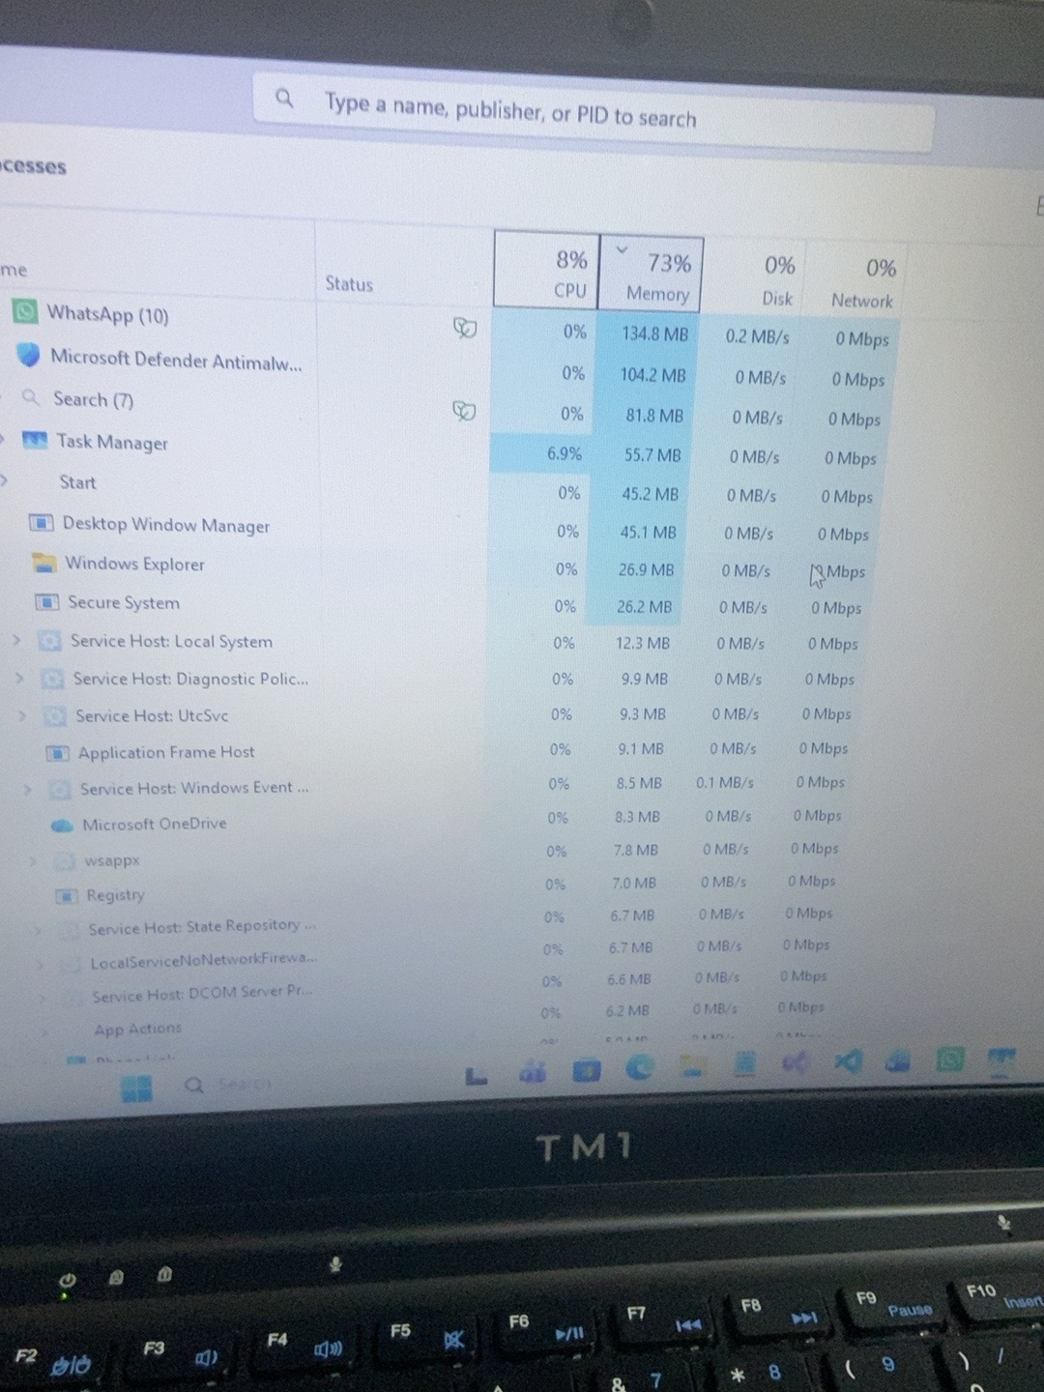
Evidence 2 – Processes view: 73% memory utilization.
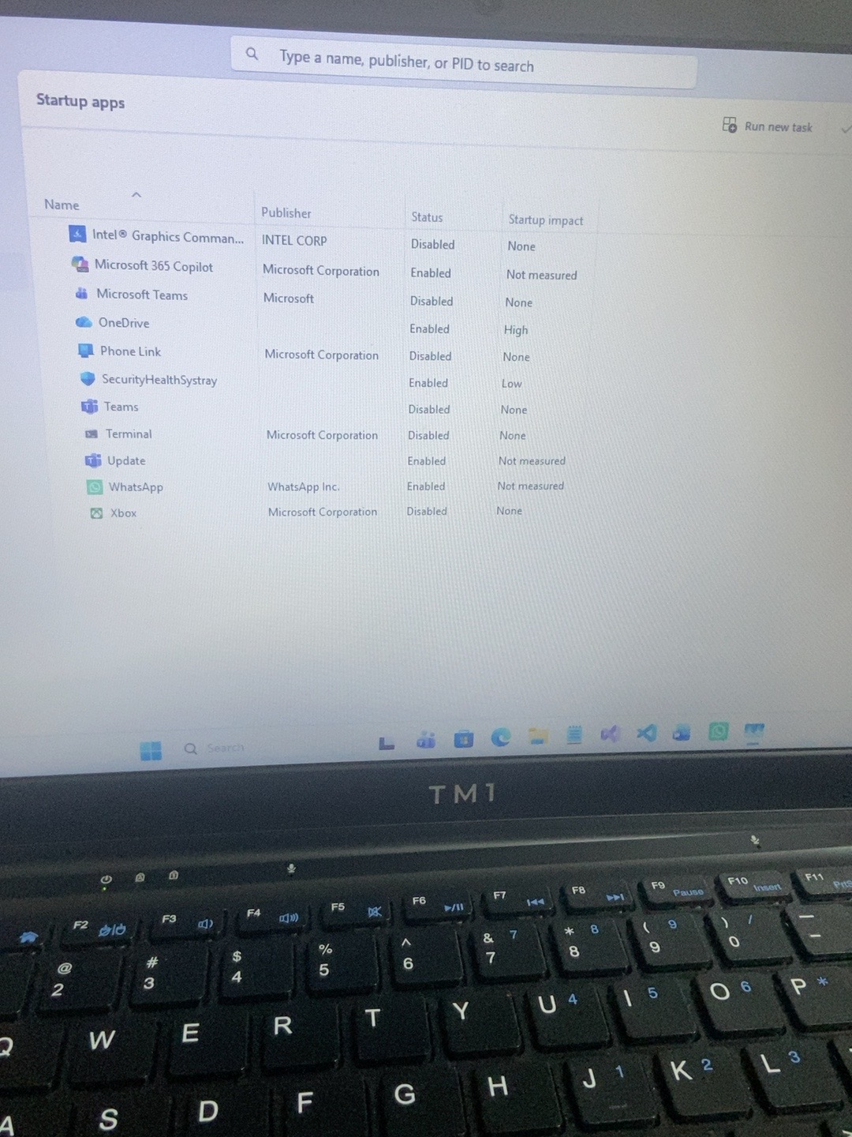
Evidence 3 – Startup apps before changes.
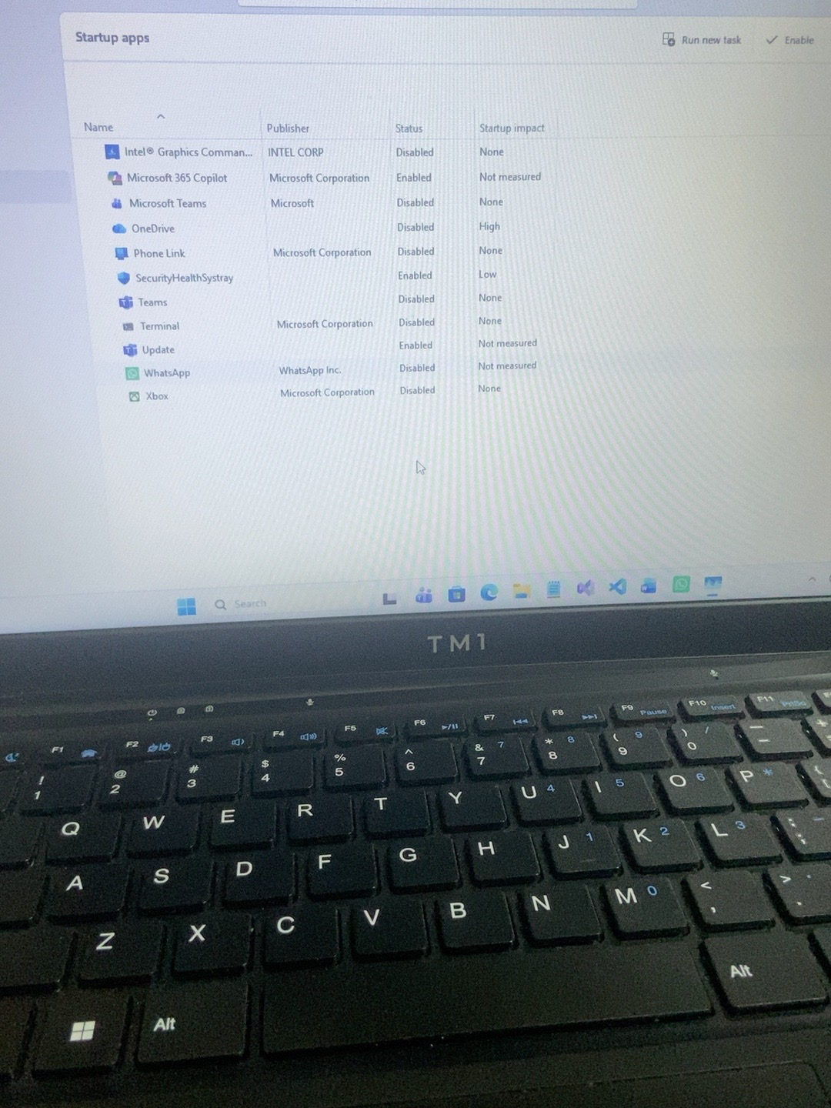
Evidence 4 – Startup apps after changes: OneDrive and WhatsApp disabled.
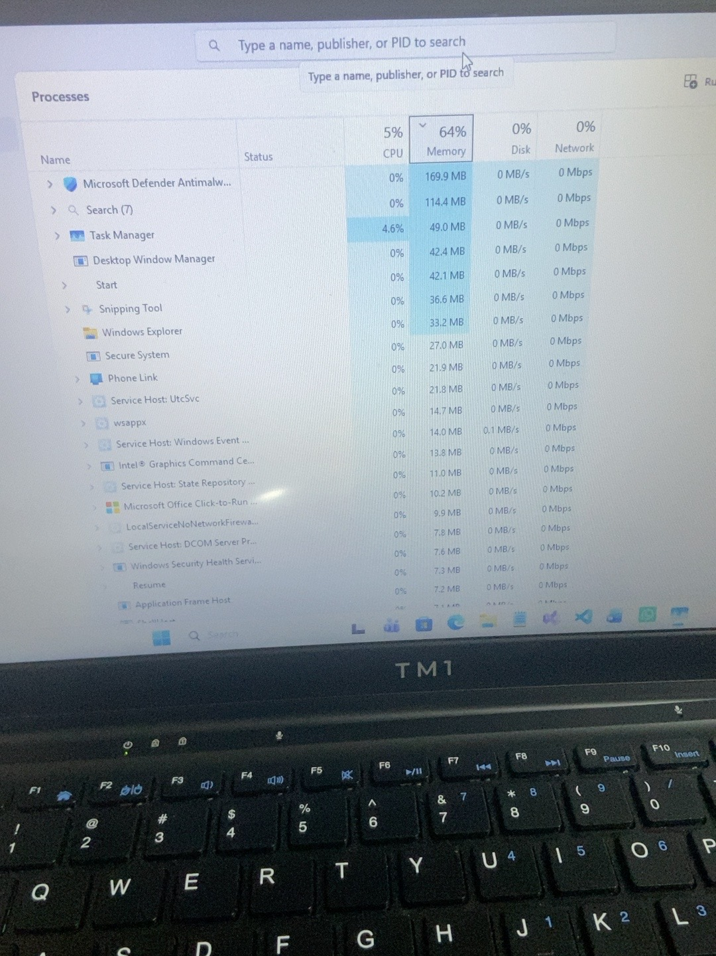
Evidence 5 – Processes after restart: 64% memory utilization, 5% CPU.
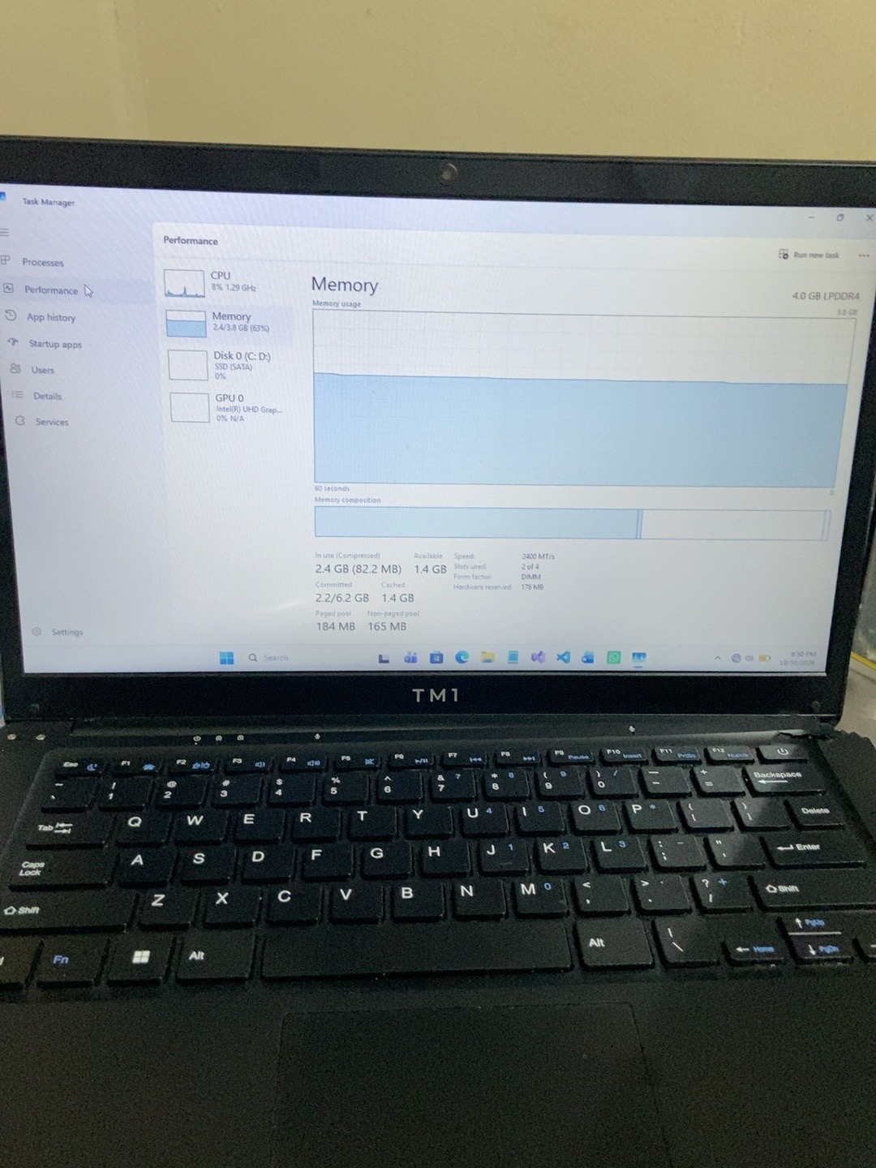
Evidence 6 – Memory after restart: 2.4 GB in use, 1.4 GB available, approximately 63%.
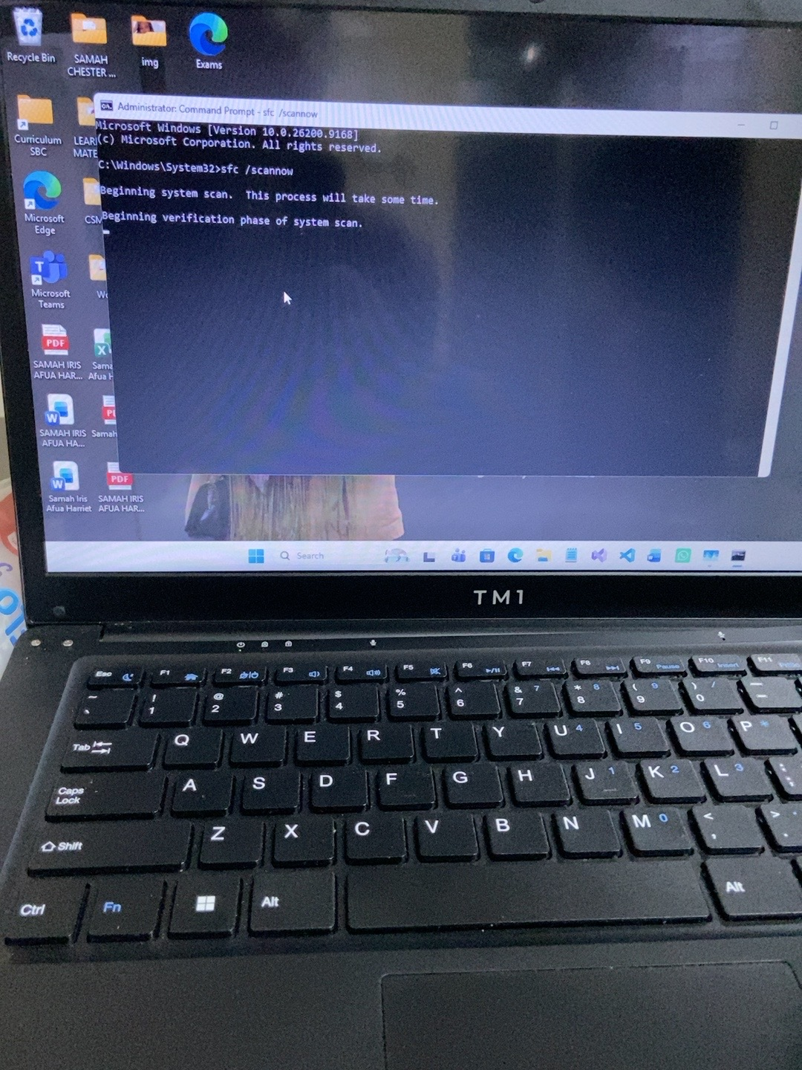
Evidence 7 – SFC scan in progress.
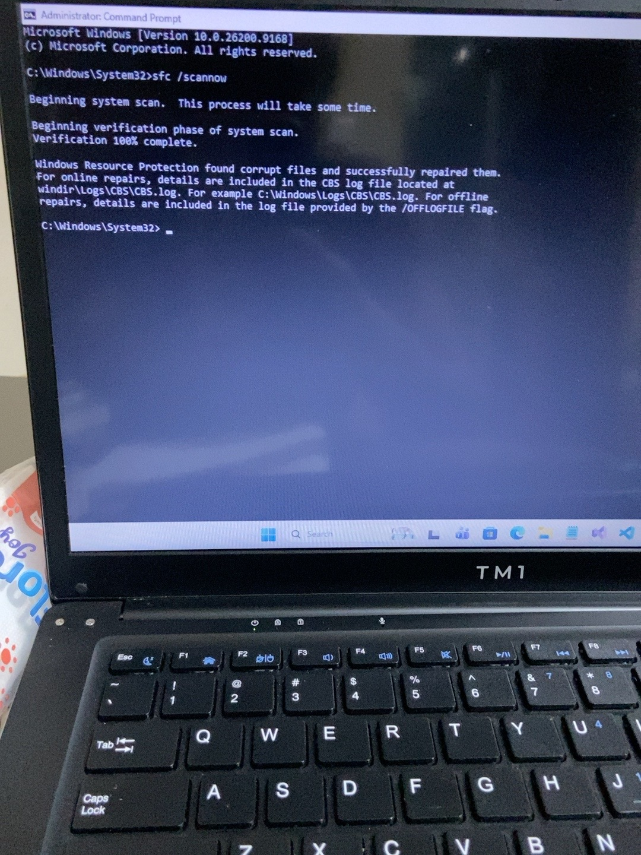
Evidence 8 – SFC completed: corrupt files found and successfully repaired.

12. Follow-up record
Add the date of the follow-up observation, whether freezing returned, and any further diagnostic results. Keep observations, actions, and possible explanations clearly distinguished.
Follow-up date | Observed performance | Freezing returned? | Additional action / notes
____________ | ____________________ | Yes / No | ________________________
____________ | ____________________ | Yes / No | ________________________

